**Chapter 4**

**PRESENTATION, ANALYSIS AND INTERPRETATION OF DATA**

This chapter presents the actual data, statistical analysis and interpretation gathered by the researchers based on the data collected from the evaluator’s feedback. The respondents were composed of three (3) IT experts, 16 grade school teachers and the principal of the TFBC School, Inc. Grade School Department. Data gathered from survey questionnaires were organized in table to reflect the reaction from the respondents.

|  |  |  |
| --- | --- | --- |
| **Table 4.0 Classification of the Respondents** | | |
|  | **Frequency** | **Percentage** |
| Teachers | 16 | 80 % |
| Principal | 1 | 5 % |
| IT Experts | 3 | 15 % |
| **Total** | **20** | **100%** |

1. **The Existing Grading system of TFBC School, Inc.**

The proponents tabulated the responses from the distributed questionnaires (see Appendix E) for gathering substantial information that served as basis of developing the proposed system. In this section, graphical representations and descriptive statistics are provided to support the data gathered. The respondents, a total of 17, were the primary and intermediate level teachers of the TFBC School, Inc. and the principal.

**1.1 TFBC School, Inc. Current Mode of Grading System**. Respondents were asked to mark the currently used grading system of the school.

|  |  |  |
| --- | --- | --- |
| **Table 4.1 Current Mode of the TFBC School, Inc. Grading System** | | |
|  | **Frequency** | **Percentage** |
| Manual | 0 | 0 % |
| Semi-Computerized | 17 | 100 % |
| Fully Computerized | 0 | 0 % |

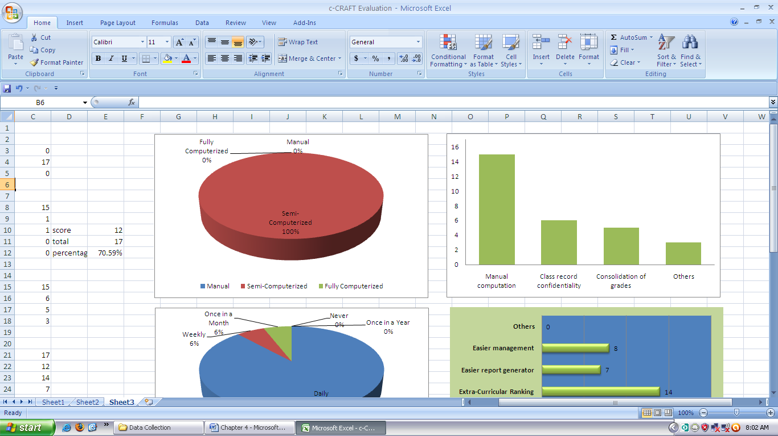

**Figure 4.0 Current Mode of the TFBC School, Inc. Grading System**

Figure 4.0 and Table 4.1 shows that 17 of the respondents or 100 percent (100%) of them marked that the grading system used in the school is semi-computerized. Therefore, the TFBC School, Inc. uses a semi-computerized mode of grading system. The system is composed of a class record and Microsoft Excel spreadsheet file for the IRP’s. Raw scores are manually computed into the class record and these computed grades from raw scores are transferred into the spreadsheet file or the IRP for subject grade computation. The class adviser then consolidates the computed subject grades and compute for the periodical grade and ranking of students.

**1.2** **Frequency of Updating Class Records**. Respondents were also asked to mark how frequent do they update their class records. The choices were classified into daily, weekly, once in a month and once in a year basis.

|  |  |  |
| --- | --- | --- |
| **Table 4.2 Frequency of Updating Class Records** | | |
|  | **Frequency** | **Percentage** |
| Daily | 15 | 88 % |
| Weekly | 1 | 6 % |
| Once in a Month | 1 | 6 % |
| Once in a Year | 0 | 0 % |
| Never | 0 | 0 % |

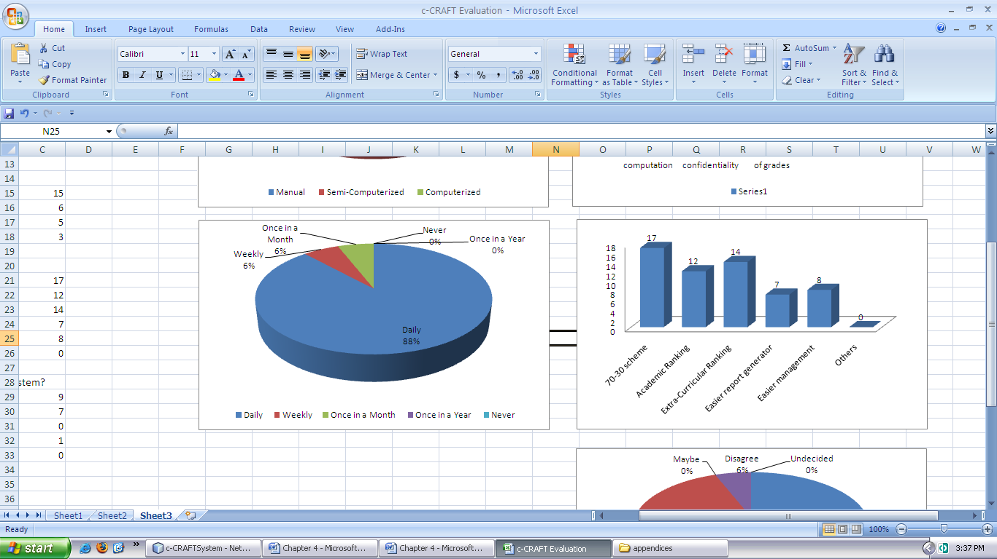

**Figure 4.1 Frequency of Updating Class Records**

Figure 4.1 and Table 4.2 shows the frequency of teachers to update and check their class records. Eighty-eight percent (88%) of them said they update their class records daily, six percent (6%) in a weekly basis and another six percent (6%) with once a month update.

**1.3 Context Diagram of the Existing System.** The context diagram of the existing system in Figure 4.2 is presented in analytical tool to identify the scope and boundary for the system and the project to be developed.

Shown in the diagram is the process undergone by the subject teacher, the class adviser and the principal with the existing system. The subject teacher inputs raw and manually computed grades in the class record book monthly and on every quarter will report printed individual rating of pupils (IRP’s) sheet for pupils using a customized Microsoft Excel file. These printed files are now collected by the class adviser for each section periodically to consolidate individual grades of students per subject. Consolidation will be then computed for quarterly ranking of students. The principal often receive IRP’s and class ranking results for checking and monitoring of accuracy of data.

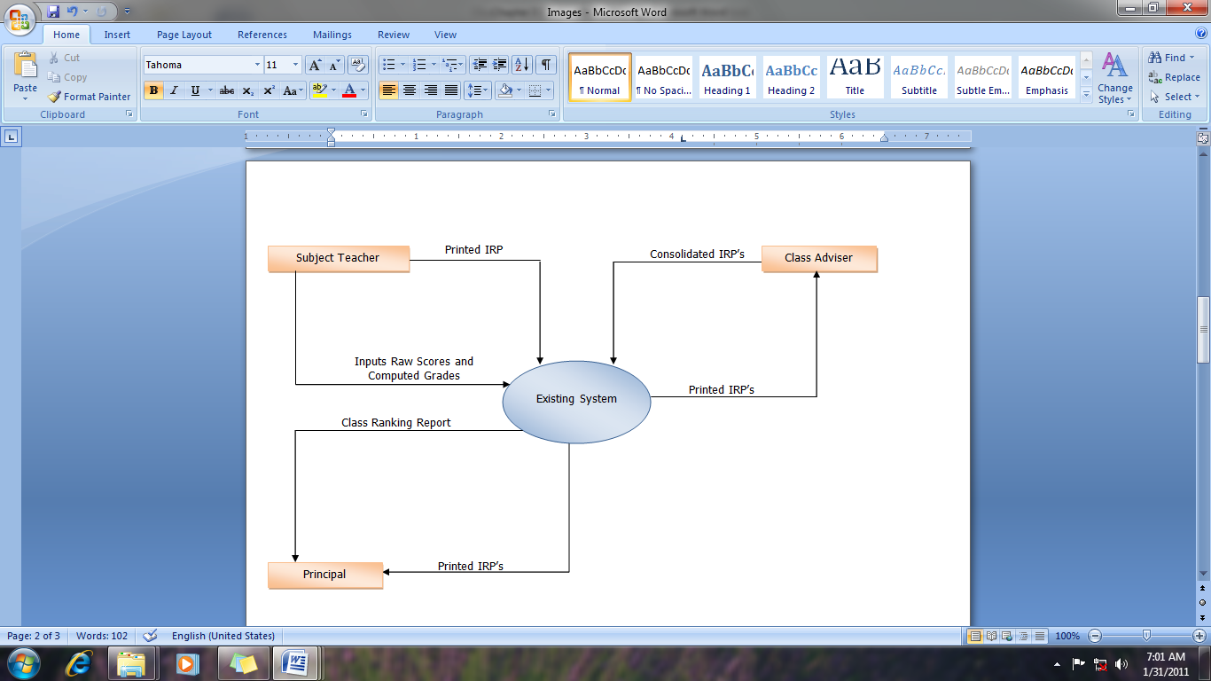

**Figure 4.2 Context Diagram of the Existing System**

1. **The Problems Encountered by the Teachers using the Existing System.** The respondentswere asked to select the problems they encounter using their current grading system using a class record and Microsoft Excel spreadsheet. Otherwise, they specify the problem if necessary.

|  |  |  |
| --- | --- | --- |
| **Table 4.3 Problems Encountered using the Existing Grading System.** | | |
|  | **Frequency** | **Percentage** |
| Manual computation of raw scores into grades | 15 | 88 % |
| Class record confidentiality | 6 | 35.29 % |
| Consolidation of grades | 5 | 29.41 % |
| Others | 3 | 17.65 % |

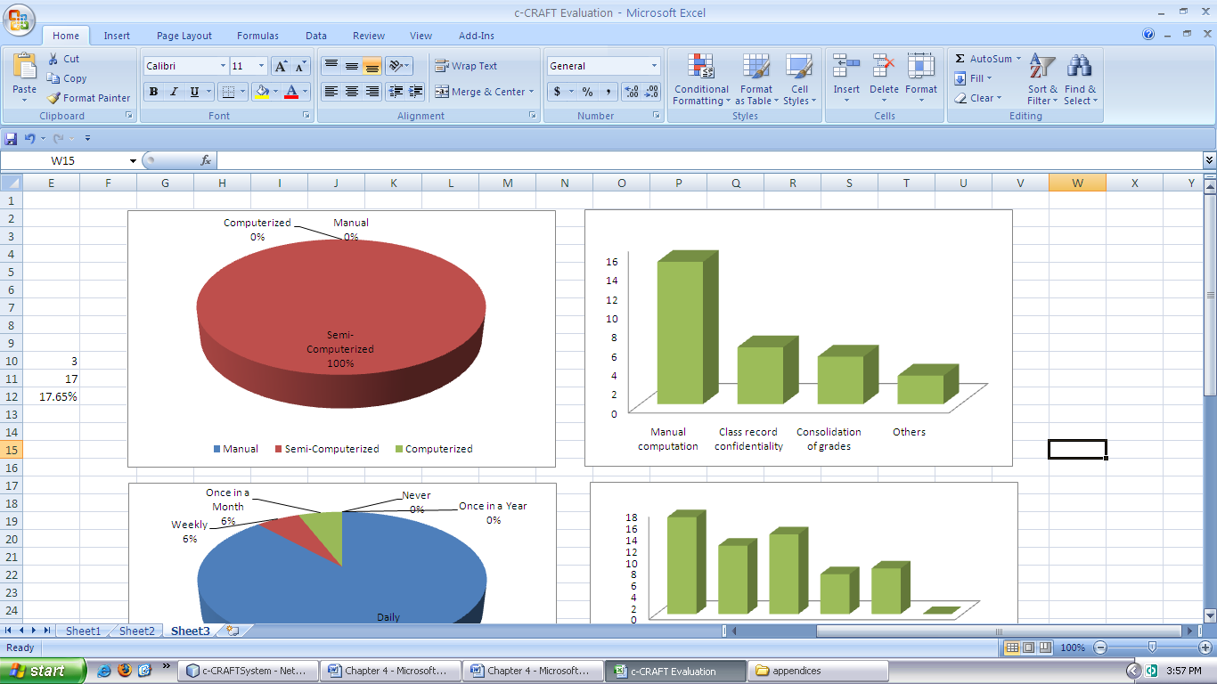

**Figure 4.3 Problems Encountered using the Existing Grading System.**

**2.1 Problems Encountered using the Existing Grading System.** Figure 4.3 and Table 4.3 shows the problems encountered by the teachers using the existing system. Eighty-eight percent (88%) of them answered that they had problems in manually computing grades. Class record confidentiality is the concern of more than 35% of respondents and 29% had problems in consolidating grades since the school is practicing team teaching. Other problem specified is the reliability of computation since the respondents manually compute raw scores into grades before they input their computations in the individual rating of pupils (IRP’s).

**2.2 Features or Functions to be Included in the Proposed System**. The respondents were also asked to select from the given features or functions that they would like to add in the proposed system. Otherwise, the respondents should specify the features of functions if necessary.

|  |  |  |
| --- | --- | --- |
| **Table 4.4 Features or Functions to be Included in the Proposed System.** | | |
|  | **Frequency** | **Percentage** |
| Others | 0 | 0 % |
| Easier management | 8 | 47.06 % |
| Easier report generator | 7 | 41.18 % |
| Extra-curricular ranking | 14 | 82.35 % |
| Academic ranking | 12 | 70.59 % |
| 70-30 scheme | 17 | 100 % |

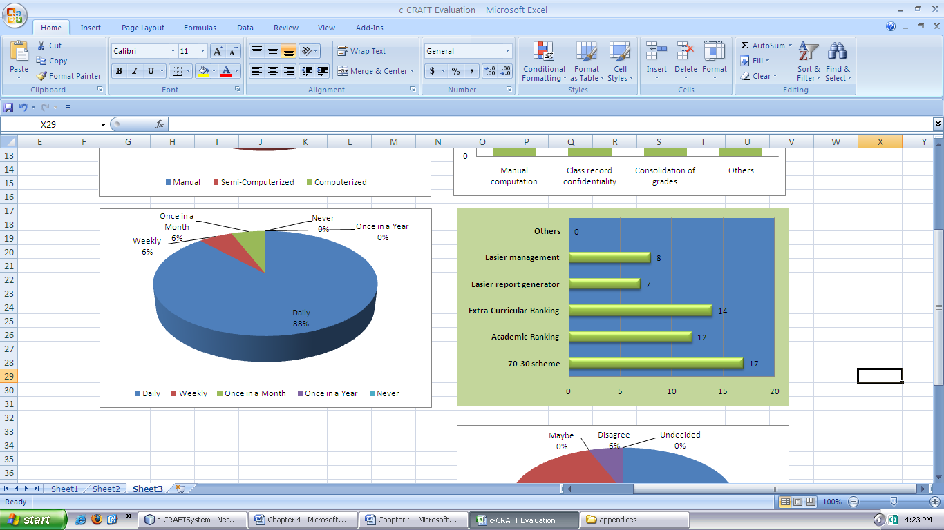

**Figure 4.4 Features or Functions to be Included in the Proposed System.**

Table 4.4 and Figure 4.4 show the features or functions that the respondents would like to be included in the proposed system. All of them wanted to include the 70-30 scheme of final ranking of student achievers. Most of them would like to include academic and extra-curricular ranking.

**2.3 Implementation of the Proposed System**. The respondents were also asked to mark if they would like to have the proposed system in their grading system.

|  |  |  |
| --- | --- | --- |
| **Table 4.5 Implementation of the Proposed System** | | |
|  | **Frequency** | **Percentage** |
| Strongly Agree | 9 | 53 % |
| Agree | 7 | 41 % |
| Maybe | 0 | 0 % |
| Undecided | 0 | 0 % |
| Disagree | 1 | 6 % |

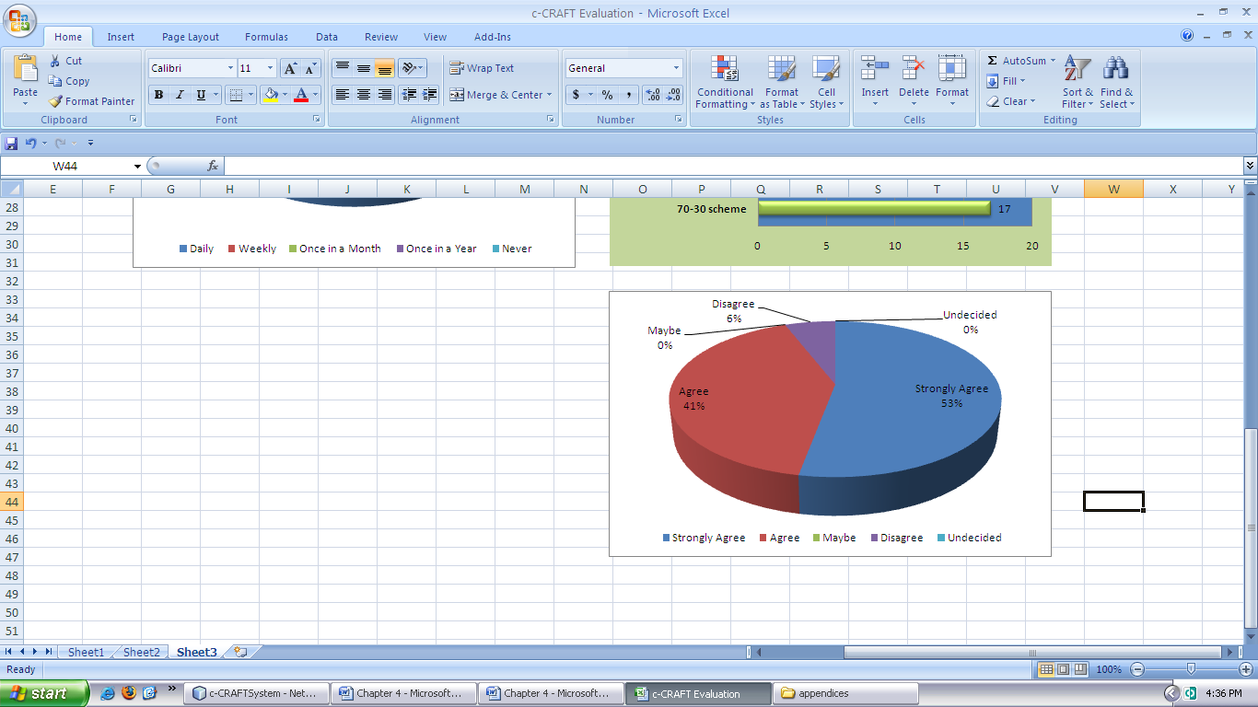

**Figure 4.5 Implementation of the Proposed System**

Table 4.5 and Figure 4.5 illustrates that majority of the respondents would like to include the proposed system in their grading system wherein fifty-three percent (53%) of them strongly agrees and forty-one percent (41%) agrees in the implementation of the proposed system.

**3. Design and Development of the Proposed System**

* 1. **Requirements Gathering and Refinement**

From these, the proponents identified the users for the system and what are the necessary elements and components concerned with the system such as reports and the class record book itself. The researchers also identified the roles of such users and the limits of their privileges by the degree of their positions within the system.

* 1. **Quick Design**

Based from the context diagram of the existing system the proponents were able to come up with another context diagram for the developed system (See Figure 4.6) that guided the group for building the prototype of the system.

As shown in the diagram, it did not require the subject teacher to compute the raw scores first before input and the class adviser do not have to consolidate the individual grading sheets from all the class subjects to manually compute the ranking of the class honor every period. In the proposed system, the principal only needs to view IRP’s and class ranking that minimizes the need for printed copies that will ultimately lessen the cost of printing.

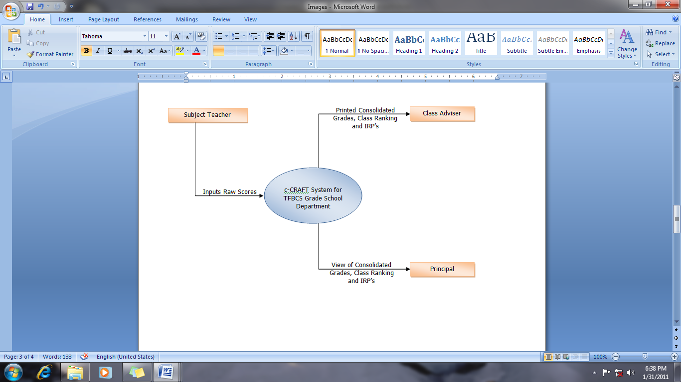

**Figure 4.6 Context Diagram of the Proposed System**

* 1. **Building Prototype**

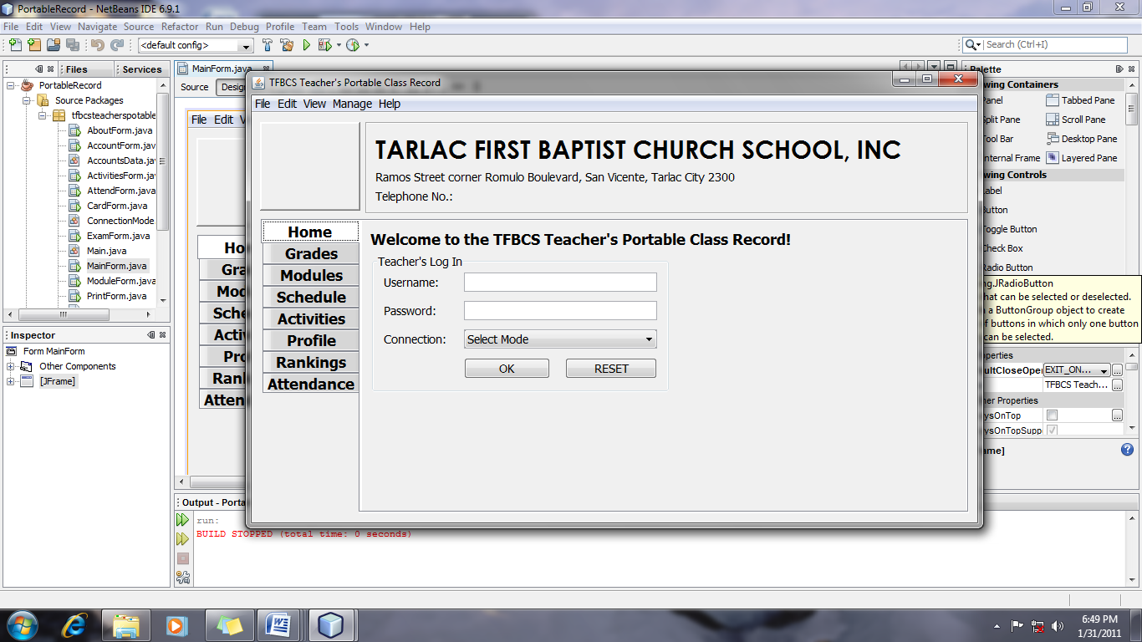

**Figure 4.7 Initial Prototype of the Proposed System (Main Window)**

Shown in Figure 4.7 is the initial prototype built by the proponents that will be evaluated by the client. It shows the visual presentation of the software side of the system to be developed and its components.

The subjects’ window, as seen in Figure 4.8, allows the administrator or the principal to manage subjects by assigning the teacher, section, room and description of the subject itself. The window also allows the user to navigate records through the navigation buttons.

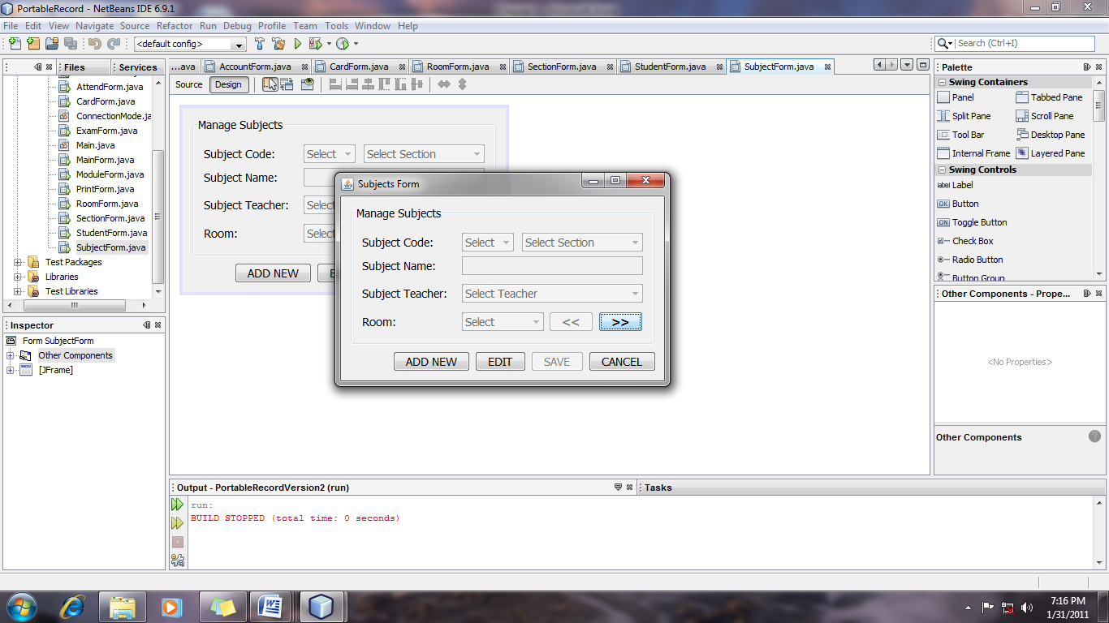

**Figure 4.8 Initial Prototype of the Proposed System (Subjects Window)**

Figure 4.9 shows the initial students’ window which allows the principal to manage students. It is necessary in adding the student to indicate the student ID, section and school for automatic assignment of the student to the existing subjects and specific records. The window also allows the user to navigate records through the navigation buttons.

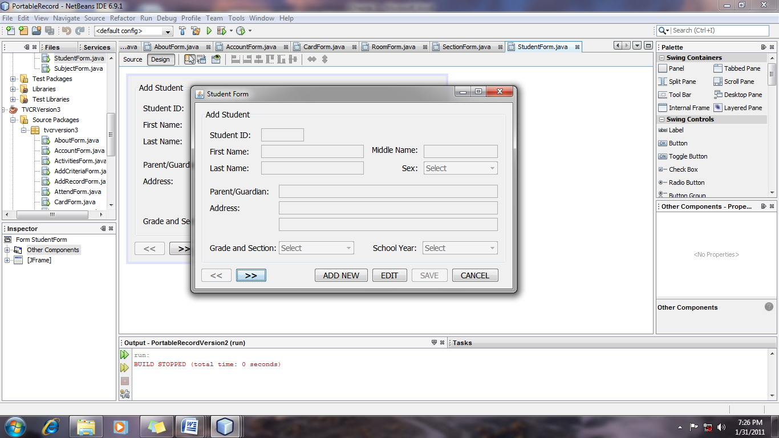

**Figure 4.9 Initial Prototype of the Proposed System (Students Window)**

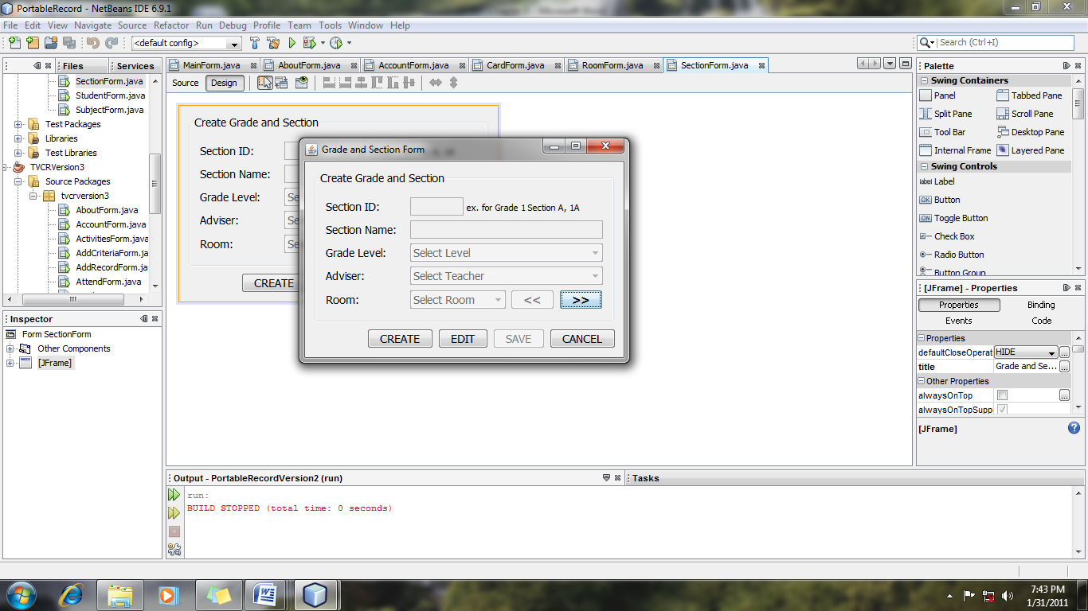The sections’ window (see Figure 4.10) enables the administrator manage section records and the assignment of the class adviser. As soon as the teacher is assigned, the teacher account is automatically configured for adviser viewer settings.

**Figure 4.10 Initial Prototype of the Proposed System (Sections Window)**

The rooms are also managed through the rooms’ management window (Figure 4.11) which allows the user to manage room information.

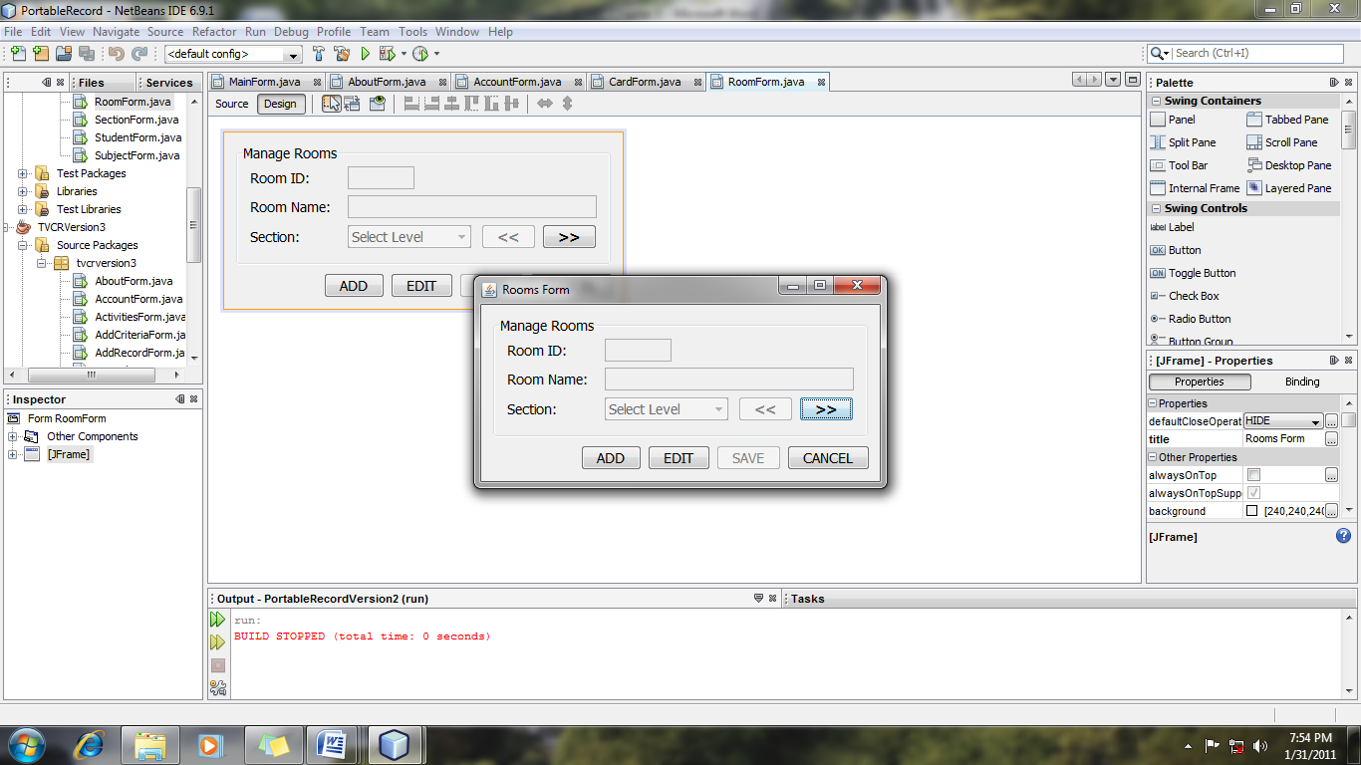

**Figure 4.11 Initial Prototype of the Proposed System (Rooms Window)**

In Figure 4.12, it shows the virtual representation of a class report card which makes it easier for the class adviser to transfer appropriate records from the system to the class report card of individual students.

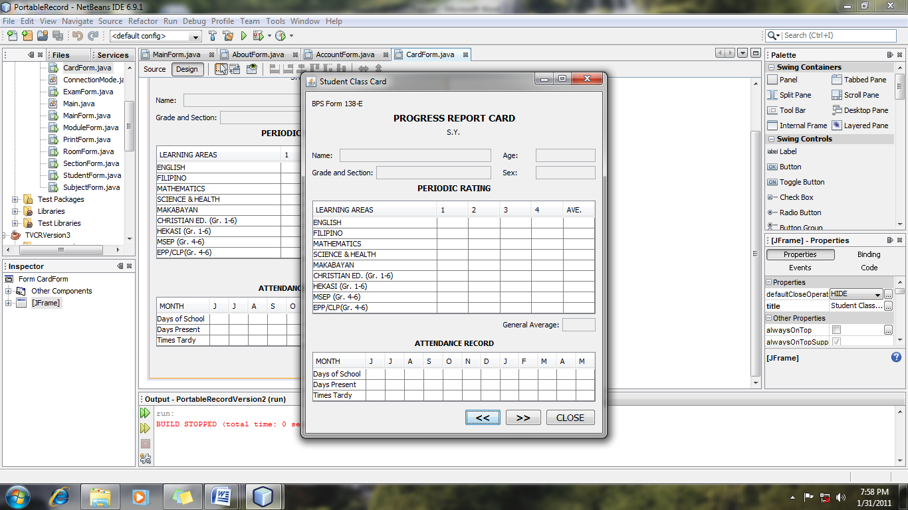

**Figure 4.12 Initial Prototype of the Proposed System (Class Card Window)**

Shown in Figure 4.13 is the accounts window wherein the principal can manage accounts of teachers that are allowed to use the system. This is also where usernames and password are set so that it can provide security over the records within the system.

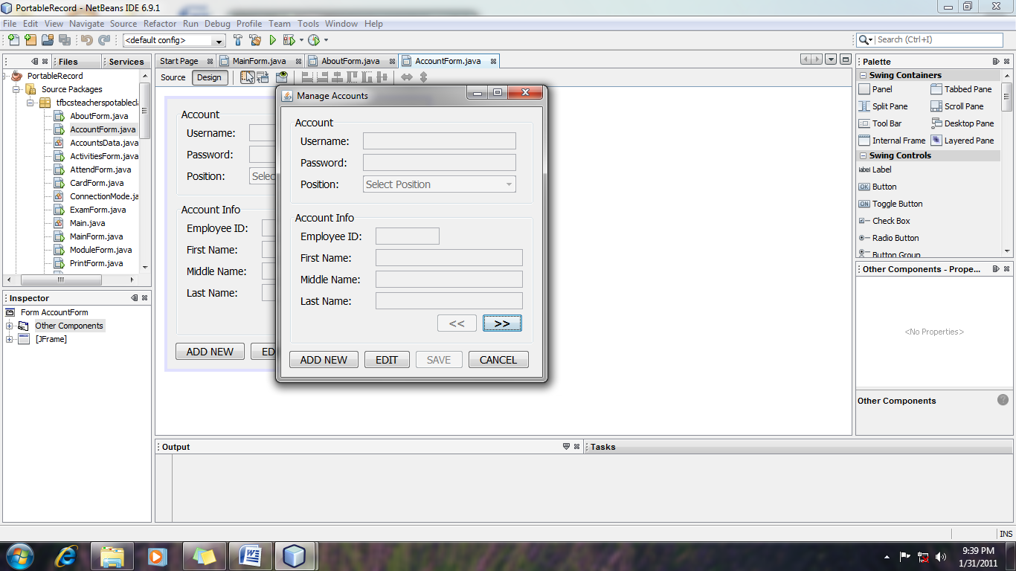

**Figure 4.13 Initial Prototype of the Proposed System (Accounts Window)**

The cross-functional diagram (see Figure 4.14 and 4.15) shows the navigation course of the users throughout the software. The diagram was based from the context diagram of the existing and proposed system and the initial prototype built by the developers for the proposed system. With these, the developers were able to separate the functions of the teachers, advisers and the principal within the exiting and developed system.

**Figure 3.9 Diagram 0 of the Prototype**

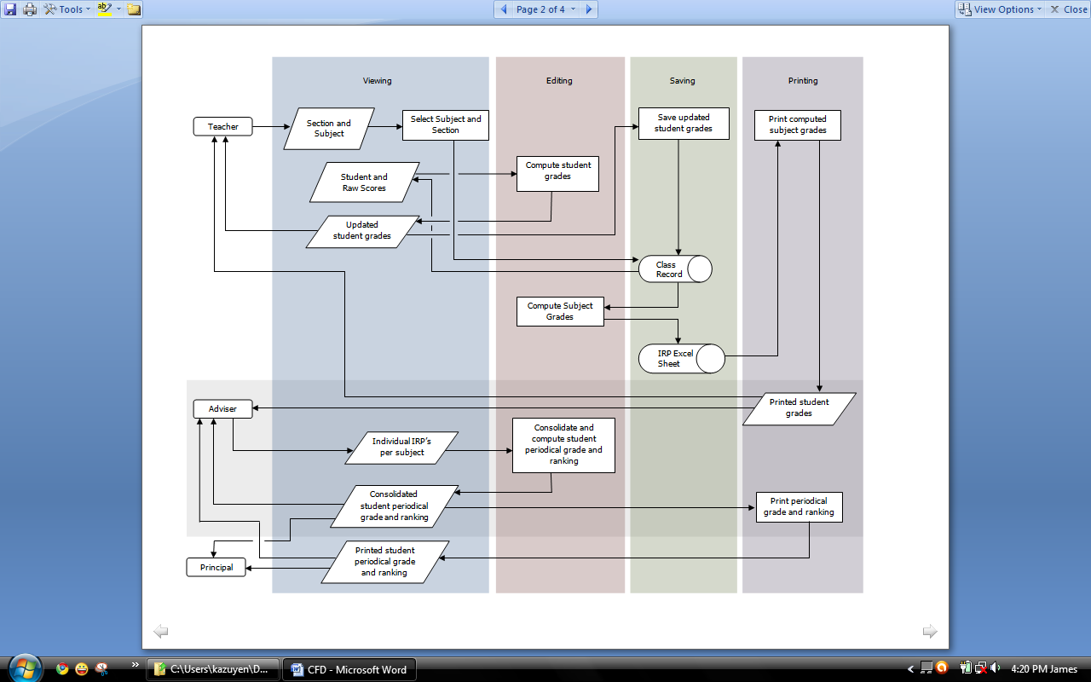

**Figure 4.14 Cross-Functional Diagram of the Existing System**

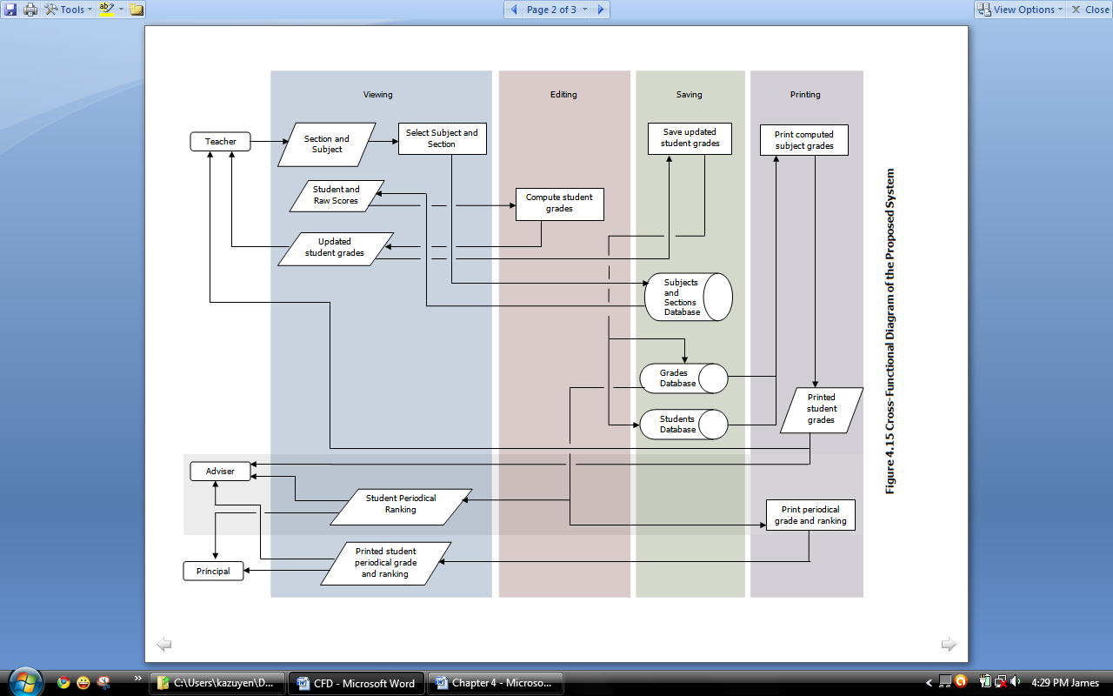

**Figure 4.14 Cross-Functional Diagram of the Developed System**

* 1. **Customer Evaluation of Prototype**

After a continuous evaluation, the proponents gathered a collection of suggestions and specifications throughout the iterations of evaluation from the client:

* Log in panel should show first before the Main window
* It should have a class record view not only the IRP.
* It should have a filter pane for searching specific subjects.
  1. **Refining Prototype**

Based on the customer’s evaluation, the developers now then refined the software according to the specifications of the client and provide another quick design for another prototype to be built and evaluated. This allowed for particular operations to be tested and refined without the enormous effort that would be required if a design were to be implemented.

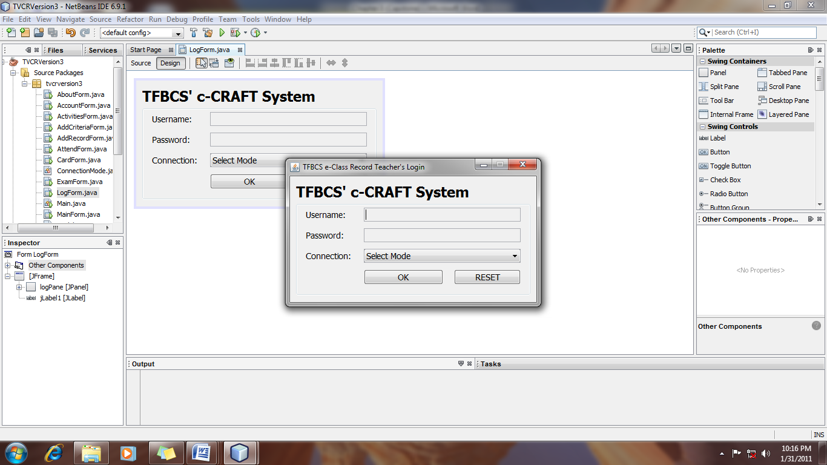Figure 4.16 shows the Log Window prototype as specified by the client. The user will initially view this screen that allows user to log in and input username and password. With this, unauthorized users will not be able to view the main window.

**Figure 4.16 Refined Prototype of the Study (Log Window)**

Refinements of the prototype were done continuously to reach the desired outcome by the clients. Content and computation verification are constantly consulted to the clients to provide accurate and reliable results on grade information on the IRP’s.

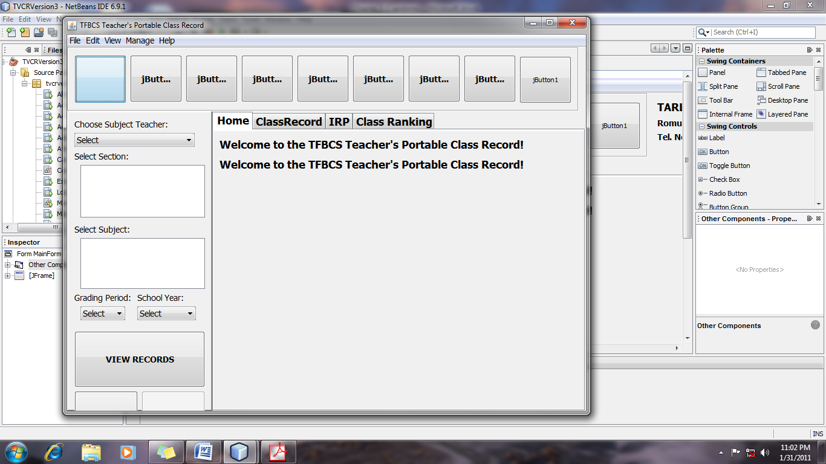

**Figure 4.17 Refined Prototype of the Study (Main Window)**

* 1. **Engineered Product**

After a finite number of iterations, the final system was ready for implementation. In this methodology, the system was evolved as a result of **periodic shuttling of information between the customer and developer**. The system was ready for evaluation by the users – the principal and teachers. After the finalizing the system, the developers laid out an implementation plan (see Appendix F) that provides a systematic process for system use. Installation, training of users, and system evaluation were undergone for the system to be ready for use.

Based on from the refinement of the prototype, the developers built the final interface and functions of the software as specified by the user’s specifications and needs. In Figure 4.18, it shows the final log in window for the system. The teacher’s log in window would be the user’s gateway to access the system by username and password authentication.

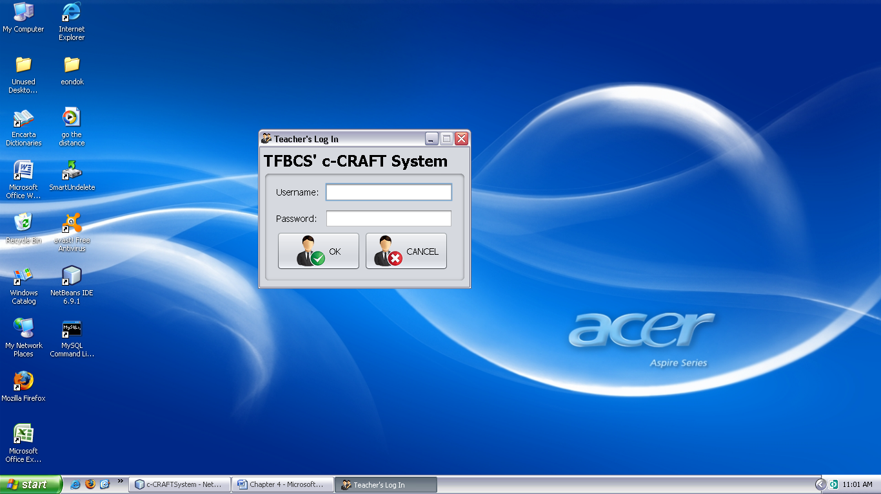

**Figure 4.18 Final Teacher’s Log In Window**

Figure 4.19, on the other hand, illustrates the interface of the main window upon log in of a valid user of the system. At the top are the shortcut buttons for manipulating the system and there includes the current date and who is currently logged in and also the menu bar which limits the access control keys of the currently logged user. The left panel is the filter panel wherein the user can filter search of records by selecting the teacher, section, subject, grading period and school year. At the bottom of the filter panel are buttons for viewing records and printing tables.

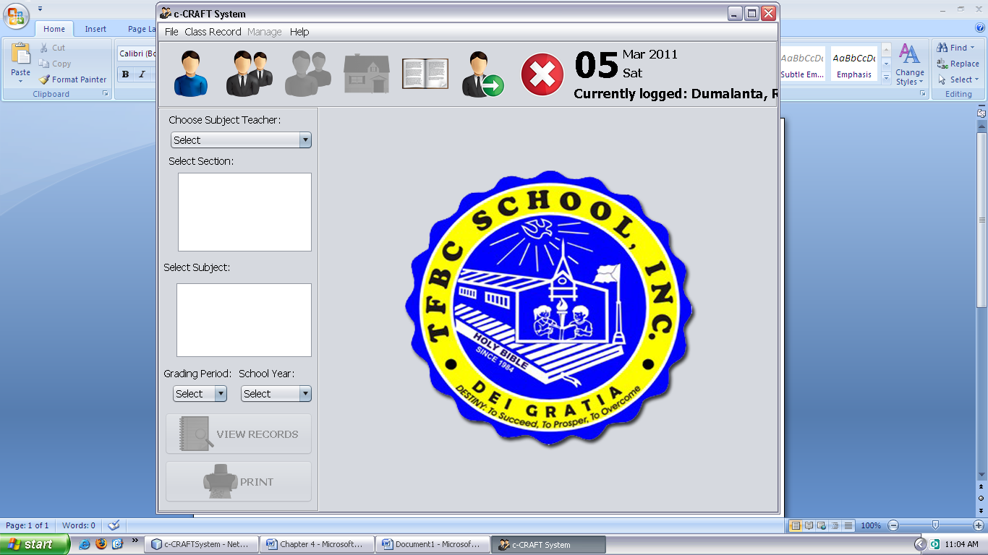

**Figure 4.19 Final Main Window**

Based from the necessary requirements in hardware and software for the system, the proponents have evaluated the client’s existing computer resources. Upon visiting and checking the computer resources of the client, the proponents found out that all of the client’s computer resources are able to meet at least if not the recommended requirements needed for the system.

**Hardware Specification.** Table 4.6 specifies the basic hardware requirements needed to run the proposed system. One could refer to this table to know what requirements had transpired during the development of the proposed system. The hardware specification is required since it is connected to the system requirements of the proposed system.

|  |  |  |  |
| --- | --- | --- | --- |
| **Components** | **Minimum** | **Recommended** | **Used** |
| Processor | Pentium 4 | Intel Celeron M or Higher | Intel Celeron M |
| RAM Memory | 128 Mb | 1 Gb or Higher | 1 Gb |
| Hard Disk Space | 40 Gb | 60 Gb or Higher | 250 Gb |
| Video Card | 64 Mb | 1 Gb or Higher | 64 Mb |
| LAN Card | 10Mbps | 100Mbps | 100Mpbs |
| Wireless LAN Card | 54Mbps | 54Mbps | 54Mbps |
| Mouse | PS/2 Compatible | USB Compatible | PS/2 Compatible |
| Keyboard | PS/2 Compatible | USB Compatible | PS/2 Compatible |

**Table 4.6 Hardware Specification**

**Software Specification.** Table 4.7 specifies the software needed in implementing the proposed system.

|  |  |  |  |
| --- | --- | --- | --- |
| **Software** | **Minimum** | **Recommended** | **Used** |
| Operating System | Microsoft Windows  XP Home Service Pack1 | Microsoft Windows  XP Professional Service Pack3 or higher | Microsoft Windows  XP Professional Service Pack2 |
| Runtime Environment | Java Runtime Environment (JRE) 6 | Java Runtime Environment (JRE) 6 | Java Runtime Environment (JRE) 6 |

**Table 4.7 Software Specifications**

**4. Evaluation of the Existing and Developed System**

Feedback from the teachers, principal and IT experts were separately shown. The data were logically grouped into different criteria and type of respondent to identify the levels of responses from each group. Weighted mean for each response was computed with 1 point each.

The existing and developed system was evaluated through based on three general criteria: Security, Efficiency and Reliability. Weighted mean and average weighted mean for each response on specific criteria were computed according to the scoring points provided for the designed Rubrics method used.

**4.1 Evaluation Summary of the Existing System**

Table 4.8 shows the evaluation summary of the existing system in terms of Security. Based from the responses, the existing system is generally fair in terms of security. The respondents find it that the system is not quite secured enough especially in data access of records and limitations on controls using the current system.

|  |  |  |  |  |  |
| --- | --- | --- | --- | --- | --- |
| **Table 4.8 Evaluation of the Existing System in Terms of Security.** | | | | | |
| **Respondents** | | **No. of Respondents** | **Score** | **Mean** | **Verbal Equivalent** |
| **Criteria: Security** | |  |  |  |  |
| 1. | Teachers | 16 | 32 | 2.133 | Fair |
| 2. | Principal | 1 | 3 | 3.000 | Satisfactory |
| 3. | IT Experts | 3 | 6 | 2.000 | Fair |
| **Weighted Mean** | | | | **2.158** | **Fair** |

Table 4.9 shows the evaluation summary of the existing system in terms of Efficiency. It shows that the existing system is fair in terms of efficiency. According to the respondents, the existing system relatively hard to organize student information, compute grades and computation consistency especially when consolidating student grades per subject. However, results show that the system is very accessible since it can be saved into a portable drive for home use.

|  |  |  |  |  |  |
| --- | --- | --- | --- | --- | --- |
| **Table 4.9 Evaluation of the Existing System in Terms of Efficiency.** | | | | | |
| **Respondents** | | **No. of Respondents** | **Score** | **Mean** | **Verbal Equivalent** |
| **Criteria: Efficiency** | |  |  |  |  |
| 1. | Teachers | 16 | 31 | 2.067 | Fair |
| 2. | Principal | 1 | 2 | 2.000 | Fair |
| 3. | IT Experts | 3 | 9 | 3.000 | Satisfactory |
| **Weighted Mean** | | | | **2.211** | **Fair** |

Table 4.10 shows the evaluation of the existing system in terms of Reliability. It shows that the existing system is fair in terms of reliability. The respondents differ from their responses based on accuracy and completeness of the information given by the system.

|  |  |  |  |  |  |
| --- | --- | --- | --- | --- | --- |
| **Table 4.10 Evaluation of the Existing System in Terms of Reliability.** | | | | | |
| **Respondents** | | **No. of Respondents** | **Score** | **Mean** | **Verbal Equivalent** |
| **Criteria: Reliability** | |  |  |  |  |
| 1. | Teachers | 16 | 32 | 2.133 | Fair |
| 2. | Principal | 1 | 3 | 3.000 | Satisfactory |
| 3. | IT Experts | 3 | 11 | 3.667 | Very Satisfactory |
| **Weighted Mean** | | | | **2.421** | **Fair** |

As presented in the evaluation summary of the existing system in Table 4.11, it has met a fair remark with an average weighted mean of 2.556 based on the Lickert’s scale. It is unanimously fair in terms of security and efficiency and relatively satisfactory in terms of reliability.

|  |  |  |  |
| --- | --- | --- | --- |
| **Table 4.11 Evaluation Summary of the Existing System** | | | |
| **Criteria** | | **Weighted Mean** | **Verbal Equivalent** |
| 1. | Security | 2.158 | Fair |
| 2. | Efficiency | 2.211 | Fair |
| 3. | Reliability | 2.421 | Fair |
| **Average Weighted Mean:** | | **2.263** | **Fair** |

**4.2 Evaluation Summary of the Developed System**

Table 4.12 shows the evaluation of the developed system in terms of Security. Based from the responses, the system is generally excellent in terms of security. The respondents find it that the system is secured especially in data access of records and limitations on controls. It has also provided a user authentication feature that would filter the users viewing settings to limit the access and control of keys of the developed system.

|  |  |  |  |  |  |
| --- | --- | --- | --- | --- | --- |
| **Table 4.12 Evaluation of the Developed System in Terms of Security.** | | | | | |
| **Respondents** | | **No. of Respondents** | **Score** | **Mean** | **Verbal Equivalent** |
| **Criteria: Security** | |  |  |  |  |
| 1. | Teachers | 16 | 73 | 4.867 | Excellent |
| 2. | Principal | 1 | 5 | 5.000 | Excellent |
| 3. | IT Experts | 3 | 14 | 4.667 | Excellent |
| **Weighted Mean** | | | | **4.842** | **Excellent** |

Table 4.13 shows the evaluation of the developed system in terms of Efficiency. It shows that the existing system is very satisfactory in terms of efficiency. According to the respondents, the developed system easy to use for organizing student information, computing of grades and consolidating student grades per subject.

|  |  |  |  |  |  |
| --- | --- | --- | --- | --- | --- |
| **Table 4.13 Evaluation of the Developed System in Terms of Efficiency.** | | | | | |
| **Respondents** | | **No. of Respondents** | **Score** | **Weighted Mean** | **Verbal Equivalent** |
| **Criteria: Efficiency** | |  |  |  |  |
| 1. | Teachers | 16 | 66 | 4.400 | Very Satisfactory |
| 2. | Principal | 1 | 5 | 5.000 | Excellent |
| 3. | IT Experts | 3 | 14 | 4.667 | Excellent |
| **Average Weighted Mean** | | | | **4.474** | **Very Satisfactory** |

Table 4.14 shows the evaluation of the developed system in terms of Reliability. It shows that the developed system is excellent in terms of reliability. The respondents agree that the developed system is reliable. It shows that it can provide accurate computation of grades from raw scores into subject grades until the accumulated periodical grade of the student with ranking.

|  |  |  |  |  |  |
| --- | --- | --- | --- | --- | --- |
| **Table 4.14 Evaluation of the Developed System in Terms of Reliability.** | | | | | |
| **Respondents** | | **No. of Respondents** | **Score** | **Mean** | **Verbal Equivalent** |
| **Criteria: Reliability** | |  |  |  |  |
| 1. | Teachers | 16 | 73 | 4.867 | Excellent |
| 2. | Principal | 1 | 5 | 5.000 | Excellent |
| 3. | IT Experts | 3 | 15 | 5.00 | Excellent |
| **Weighted Mean** | | | | **4.895** | **Excellent** |

Presented in Table 4.15 is the evaluation summary of the developed system. It has an average weighted mean of 4.830 that is verbally equivalent to excellent which shows that the developed system is excellent in terms of security, efficiency and reliability.

|  |  |  |  |
| --- | --- | --- | --- |
| **Table 4.15 Evaluation Summary of the Proposed System** | | | |
| **Criteria** | | **Weighted Mean** | **Verbal Equivalent** |
| 1. | Security | 4.842 | Excellent |
| 2. | Efficiency | 4.474 | Very Satisfactory |
| 3. | Reliability | 4.895 | Excellent |
| **Average Weighted Mean:** | | **4.737** | **Excellent** |

**4.3 Evaluation Summary of the Existing and Proposed System**

Shown in Figure 4.20 is the graphical presentation of the results acquired from the evaluation of the existing and developed system in terms of security, efficiency and reliability. The figure clearly shows that the developed system is operationally feasible for implementation.

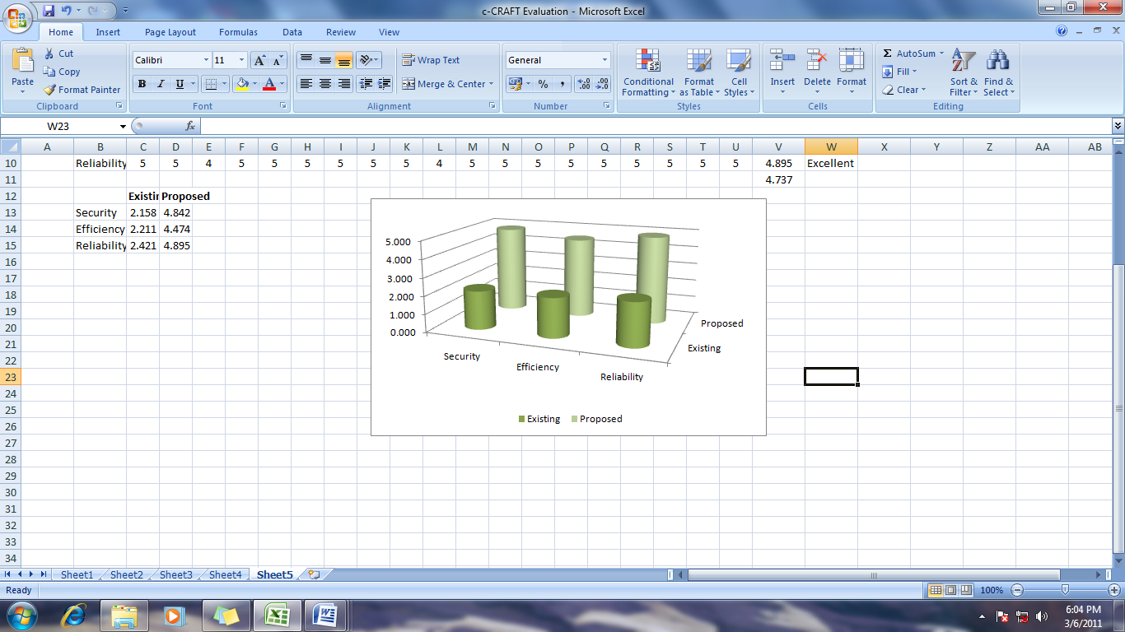

**Figure 4.20 Evaluation Summary of the Existing and Developed System**

Shown in Table 4.16 are the evaluation summary of the existing and the developed system. Based from the results, the existing system is rated as generally good as a system. On the other hand, the developed system is generally excellent as a class record and grading system in terms of security, efficiency and reliability.

|  |  |  |  |  |  |  |  |
| --- | --- | --- | --- | --- | --- | --- | --- |
| **Table 4.16 Evaluation Summary of the Existing and Developed System** | | | | | | | |
| **Existing System** | | | | **Developed System** | | | |
| **Criteria** | | **Weighted Mean** | **Verbal Equivalent** | **Criteria** | | **Weighted Mean** | **Verbal Equivalent** |
| 1. | Security | 2.158 | Fair | 1. | Security | 4.842 | Excellent |
| 2. | Efficiency | 2.211 | Fair | 2. | Efficiency | 4.474 | Very Satisfactory |
| 3. | Reliability | 2.421 | Fair | 3. | Reliability | 4.895 | Excellent |
| **Average Weighted Mean:** | | **2.263** | **Fair** | **Average Weighted Mean:** | | **4.737** | **Excellent** |

From these results, the data was treated with Student’s t-test to test the formulated hypothesis. Since the value of t-computed (tc) which is 30.87 is greater than the t-tabulated (tt) which is (1.96); whose calculation can be seen on the computation of t-test (see Appendix I), the null hypothesis would be rejected, and the alternative hypothesis would be accepted.